On 6 Sept’17, Penfabric’s MD Mr. HS Teh has a conducted motivational talk to Sales’s staff on the “Essence of An Excellent Sales Person”.

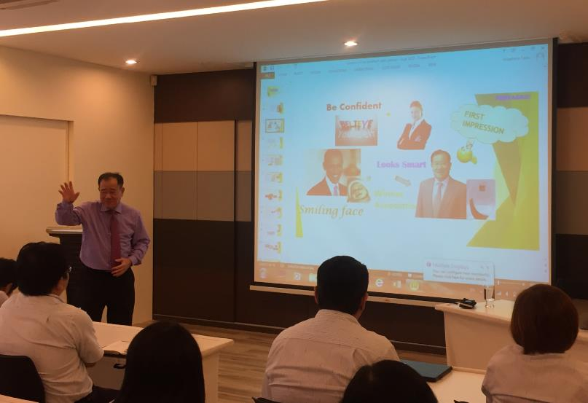
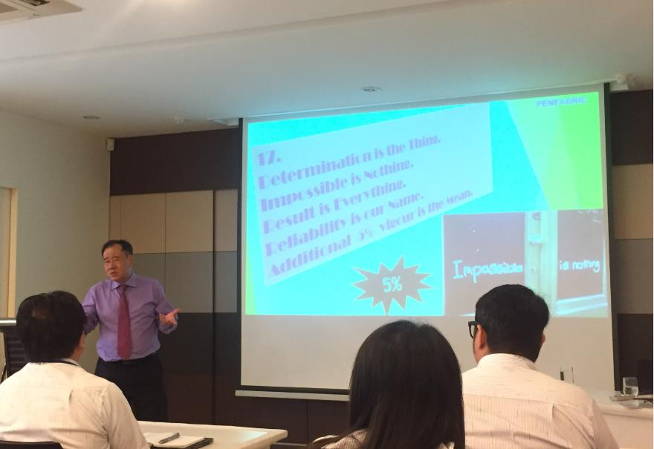
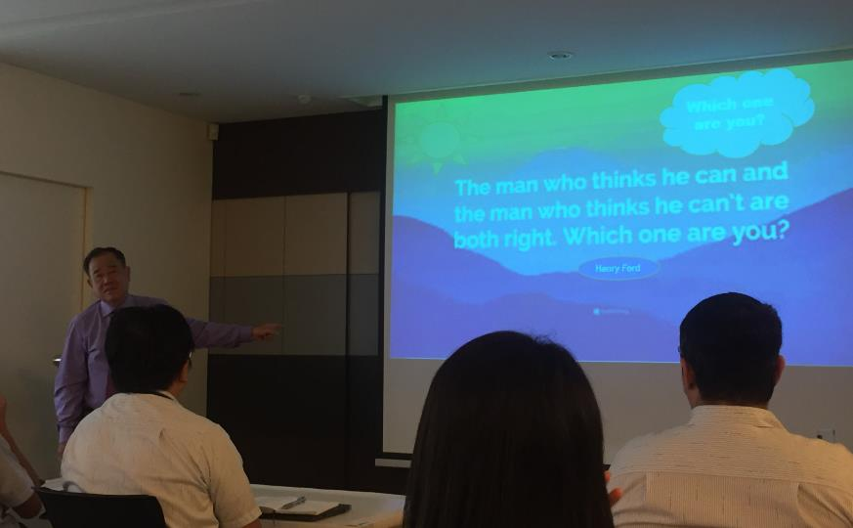
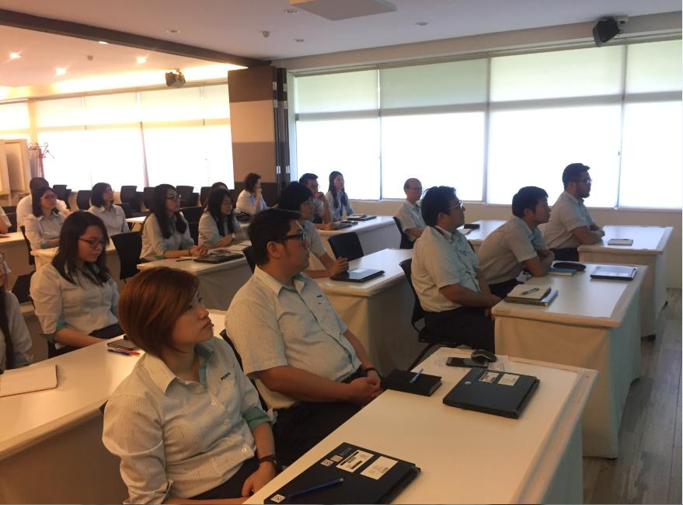
Click here for details :

